MATERIAL REQUIRED

(TRAFFIC LIGHT)

* Bread Board

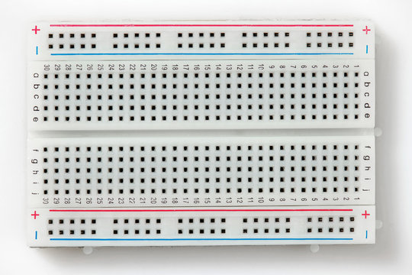

* 3 LEDs (Red, Yellow, Green)

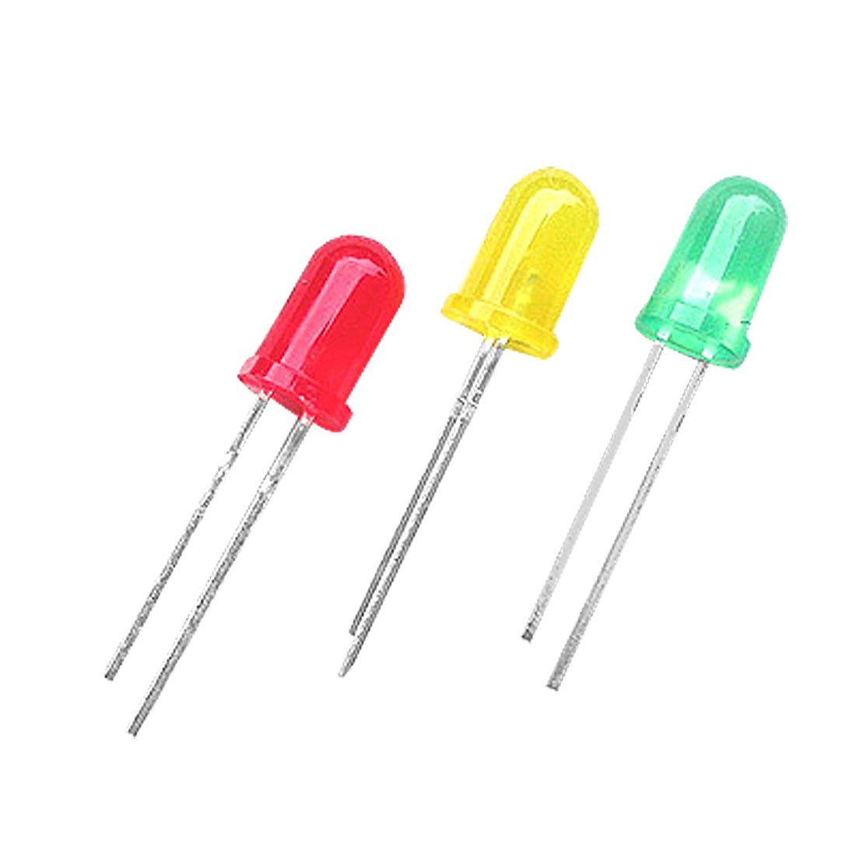

* Resistors

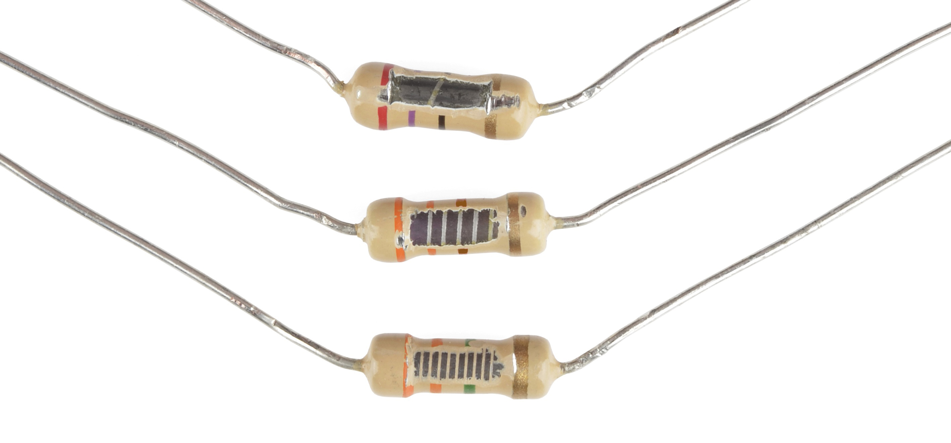

* Arduino UNO and connection cord

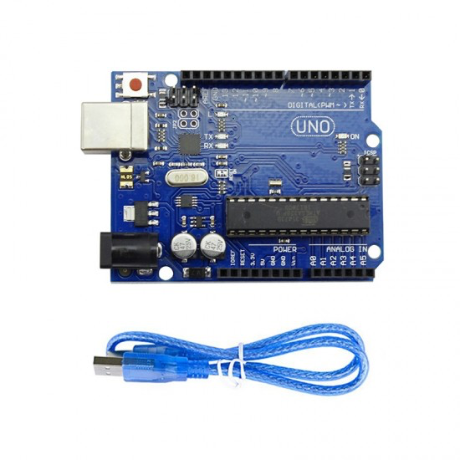

* Jumper wires